The annual Q methodology conference was hosted by Glasgow Caledonian University’s Yunus Centre for Social Business & Health, 6th – 9th September 2017.
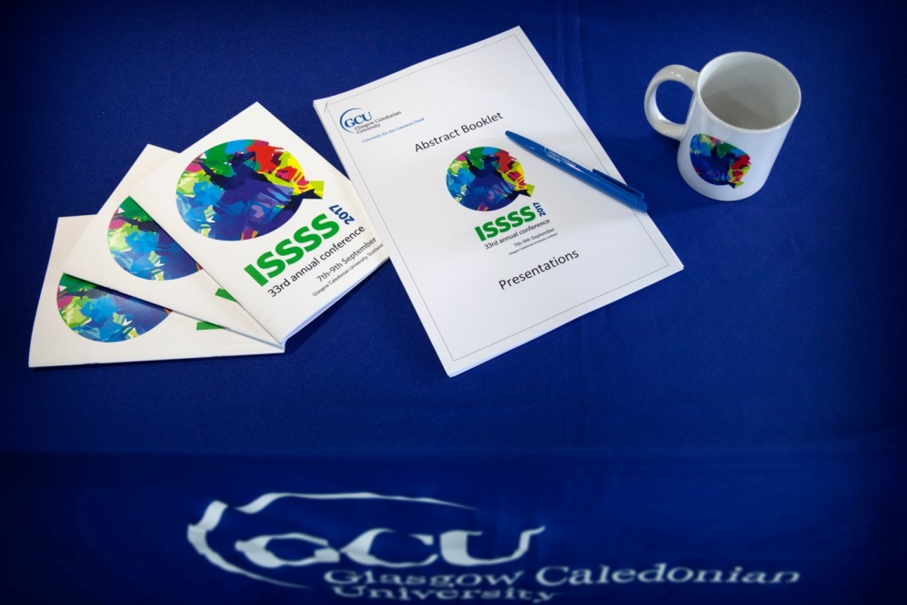
Q conference programme 2017
Pre-conference workshops took place on Wednesday 6th September 2017 and covered introductory methods (Helen Mason & Neil McHugh); Software (Max Held, Noori Aktar Danesh & Byung Lee); and advanced (Steven Brown & Jim Good).
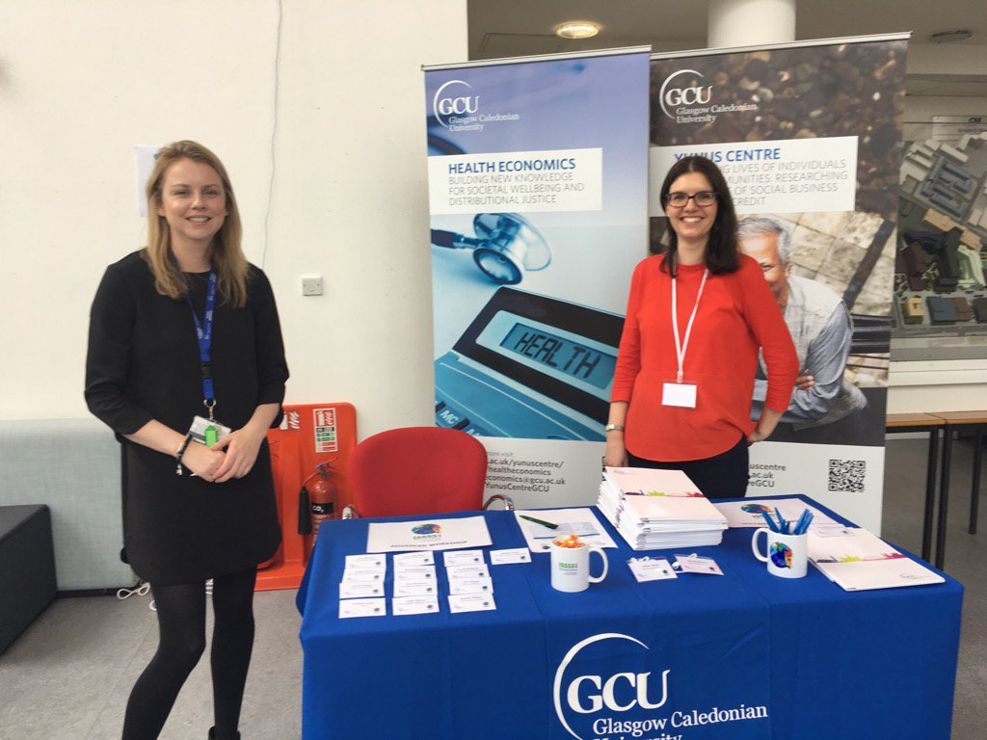
Karen McDairmant (Yunus Centre Administrator) and Helen Mason (Reader in Health Economics) welcome pre-conference workshop delegates

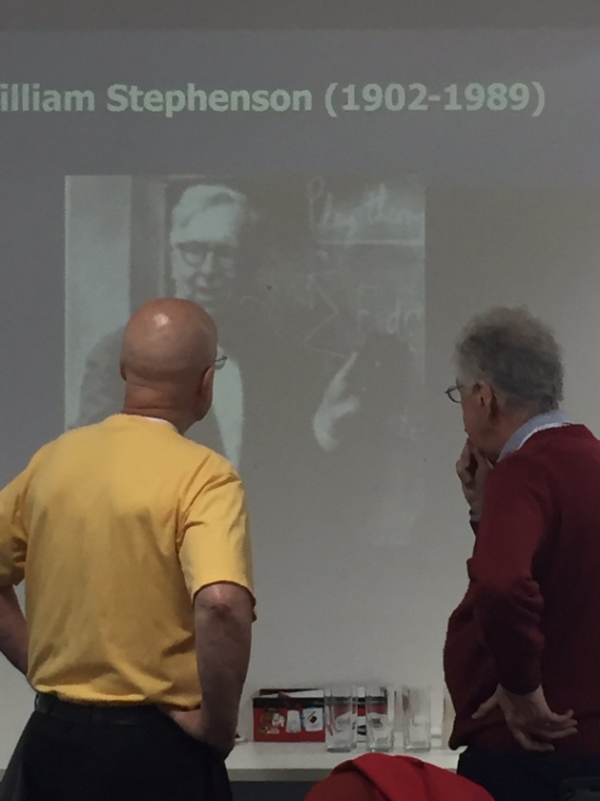

Professors Steven Brown and James Good prepare for the Advanced Workshop in Q methodology

The conference was opened by Professor Cam Donaldson Vice Principal PVC (Research) and Yunus Chair in Social Business & Health and Professor Rachel Baker, Director of the Yunus Centre for Social Business and Health.

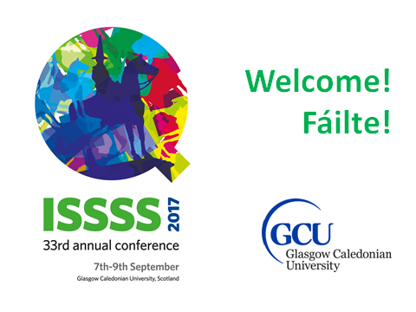
The keynote speaker Job van Exel looked back and forward and raised challenges for those working with Q methodology in relation to publications, technology and software. 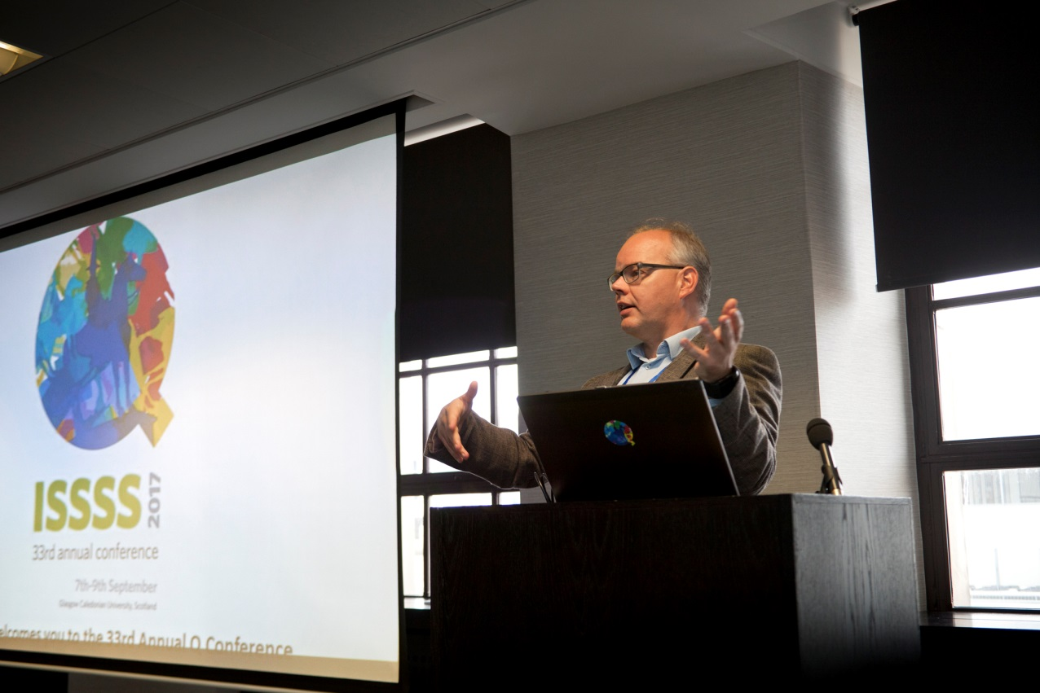

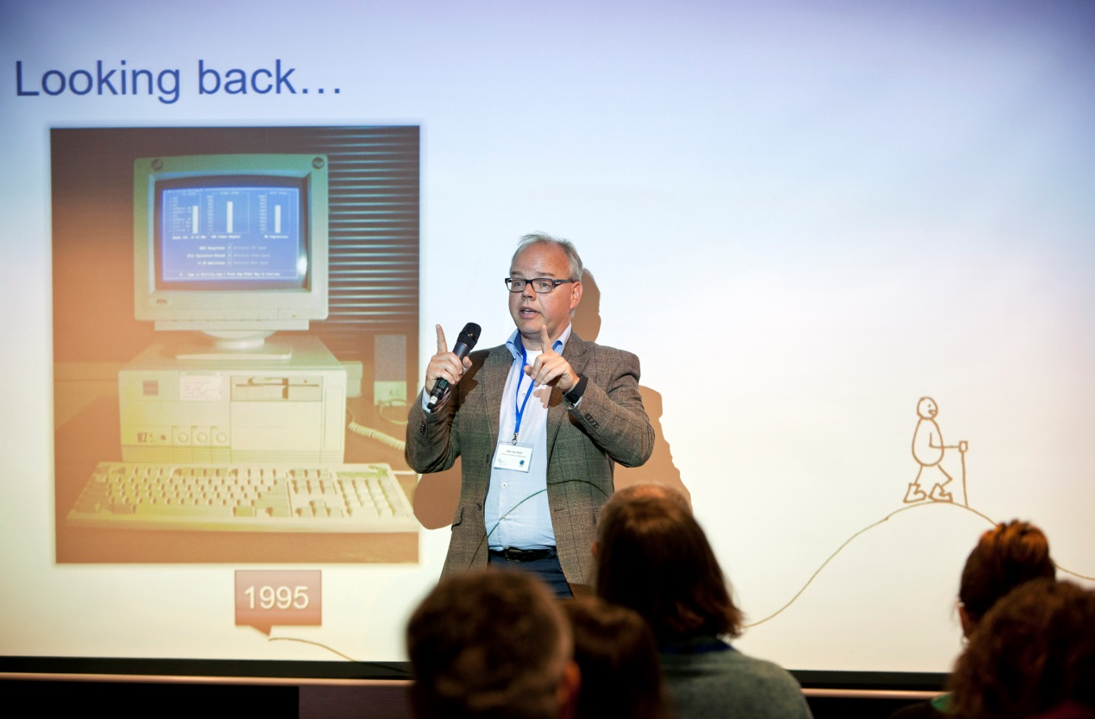
After two days of stimulating presentations and discussion, the conference dinner was held at the National Piping Centre and followed by a ceilidh.
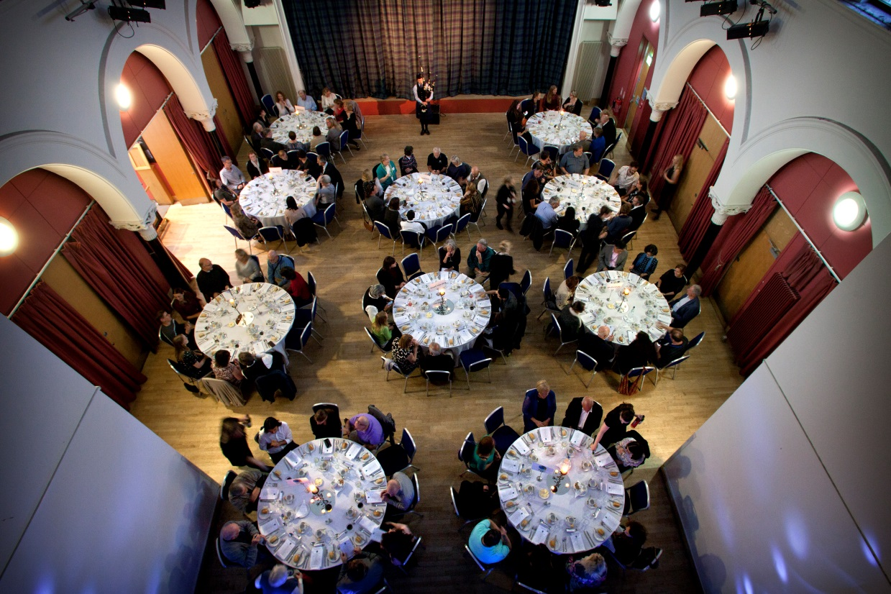

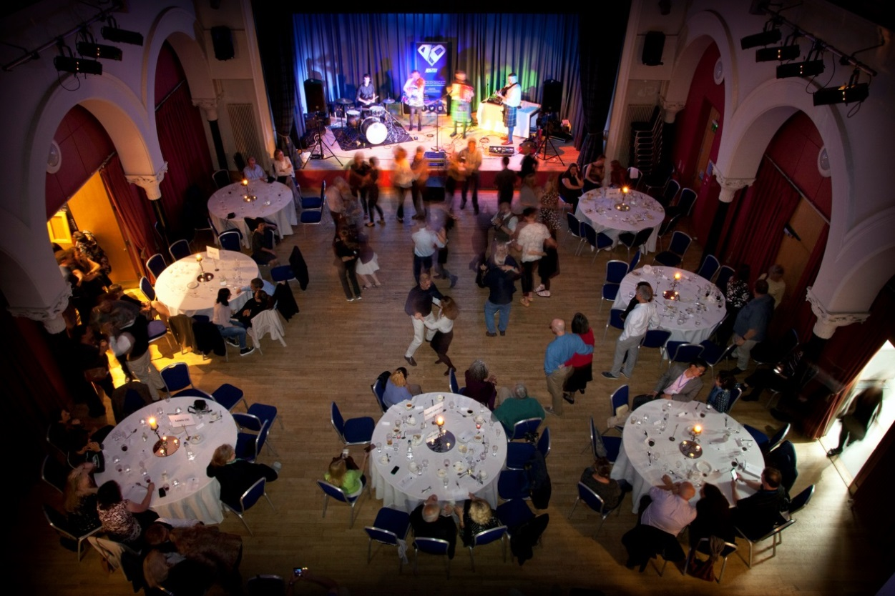

The GCU team were delighted to welcome members of Professor Stephenson’s family to Glasgow.
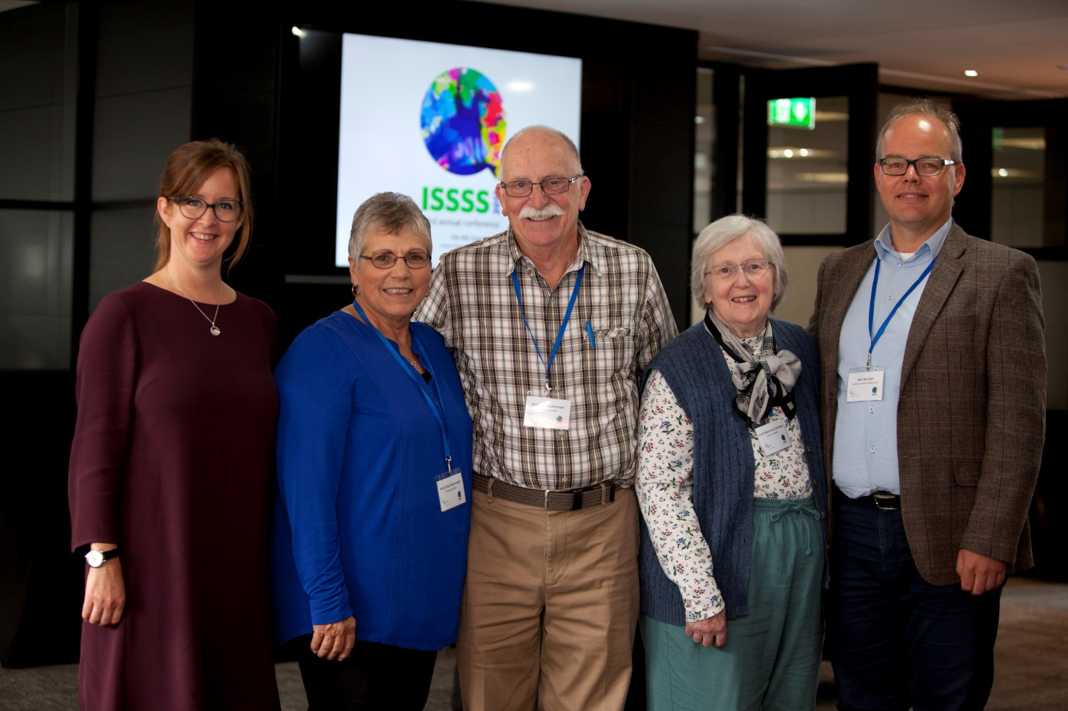
Professor Rachel Baker (Director Yunus Centre for Social Business and Health) with Mary Ellen and Richard Stephenson, Averil Schreiber (Stephenson) and Professor Job van Exel (Keynote speaker and Professor of Economics and Values at Erasmus University Rotterdam).

